**Musawakhe Andrew Nzama**

**Practical 1 - Bright Light - Data Analytics Coding Practical**

**SQL Fundamentals (Snowflake-Basic SQL Syntax)**

Q1. Display all columns for all transactions. Expected output: All columns

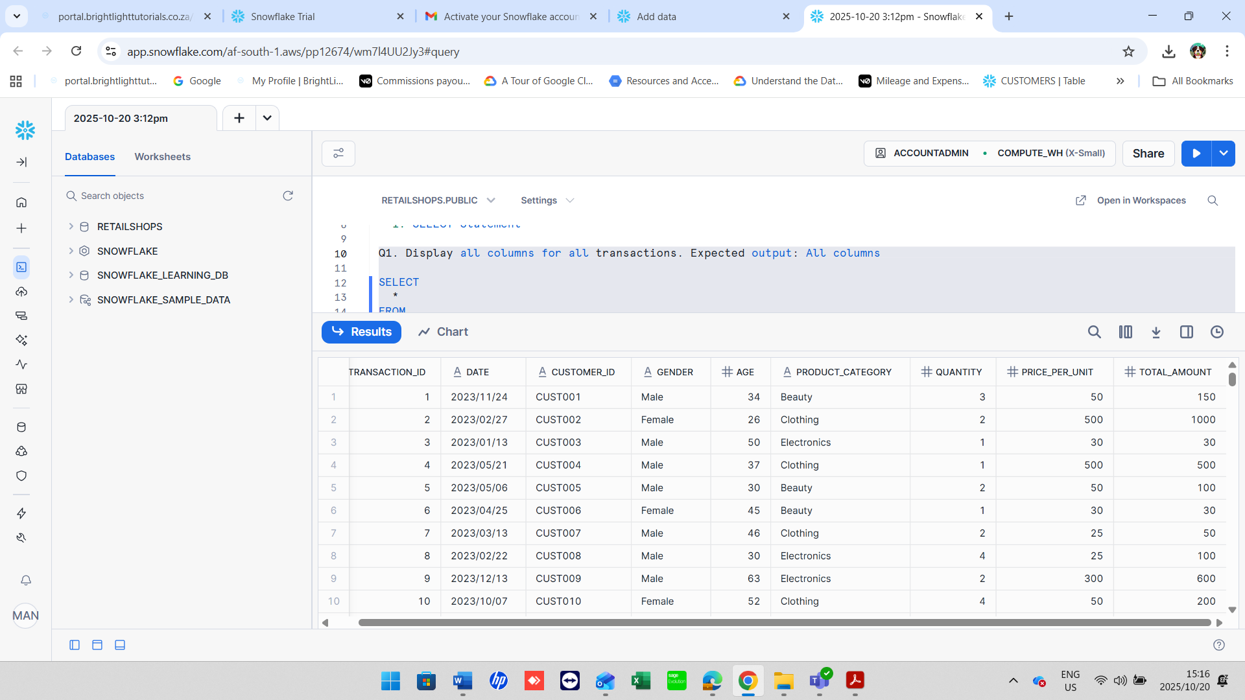

**Q2.** Display only the Transaction ID, Date, and Customer ID for all records. *Expected output:* Transaction ID, Date, Customer ID

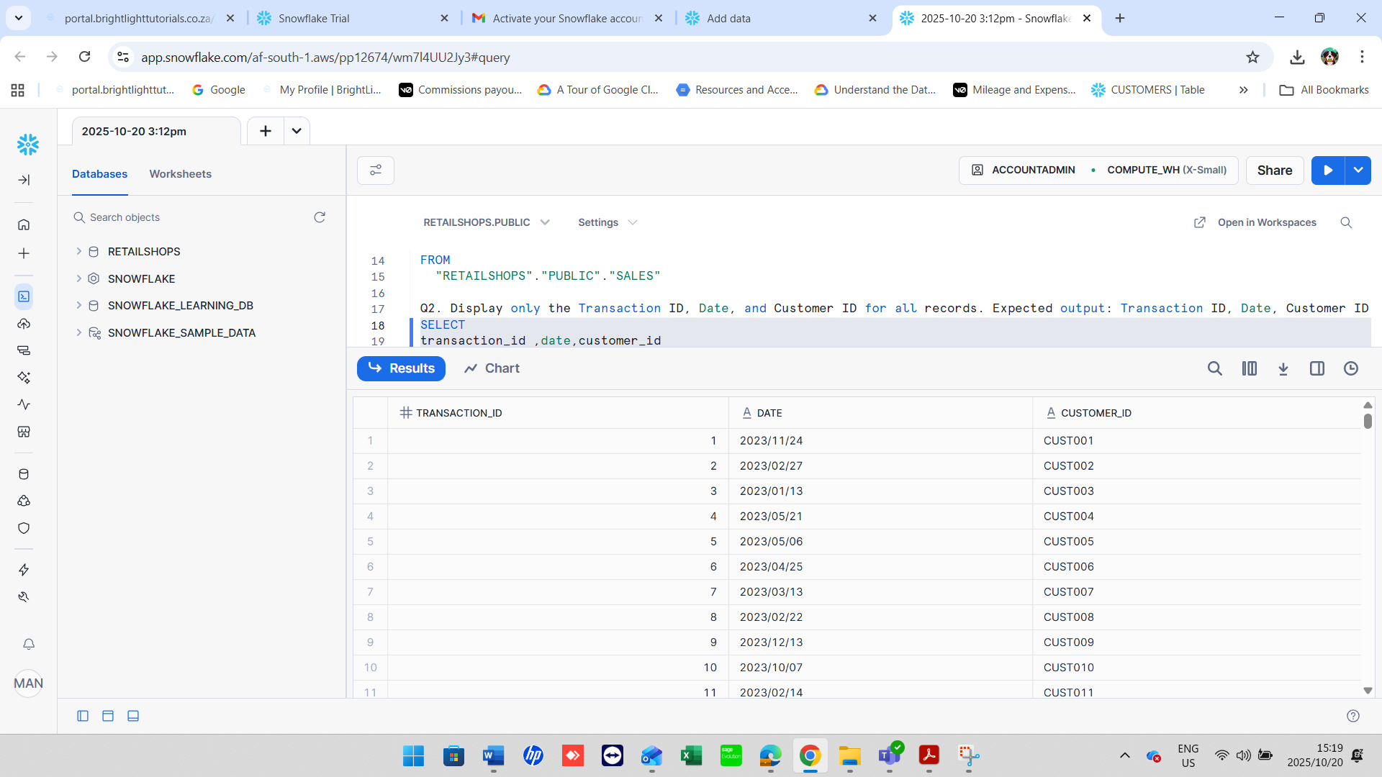

**2. SELECT DISTINCT Statement**

**Q3.** Display all the distinct product categories in the dataset. *Expected output:* Product Category

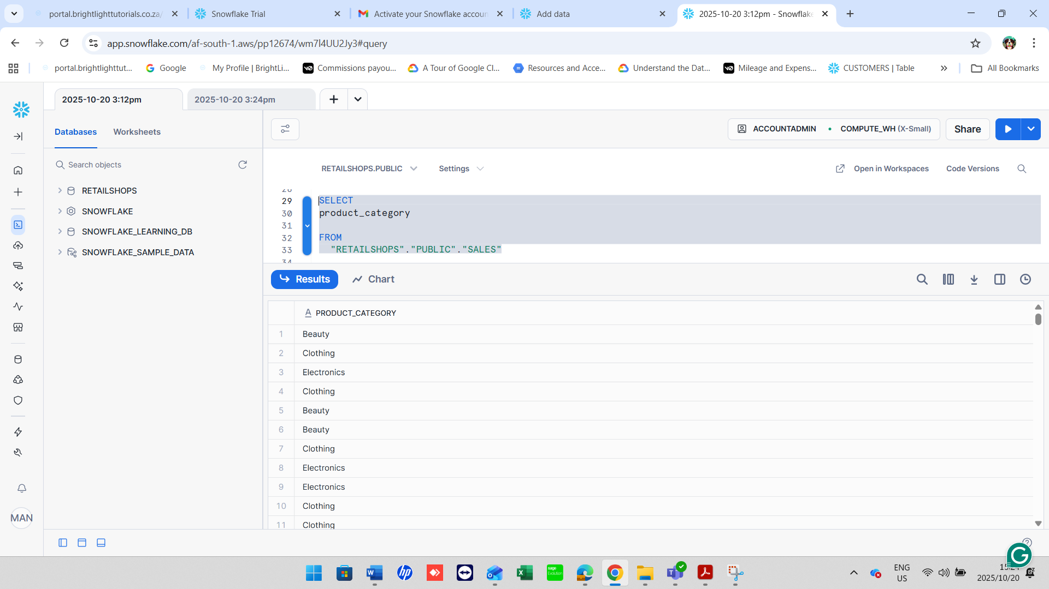

**Q4.** Display all the distinct gender values in the dataset. *Expected output:* Gender

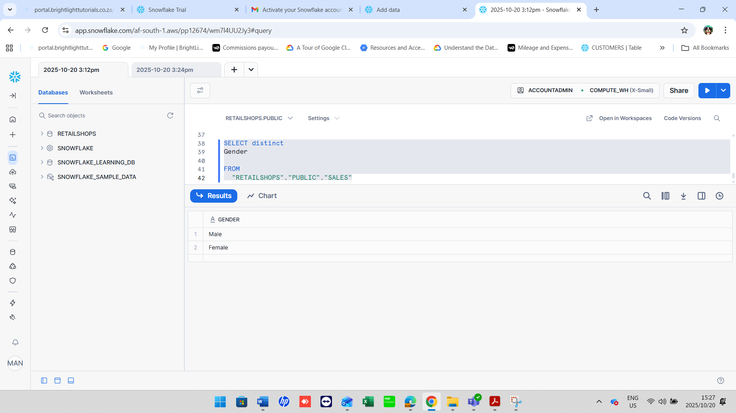

**3. WHERE Clause**

**Q5.** Display all transactions where the Age is greater than 40. *Expected output:* All columns

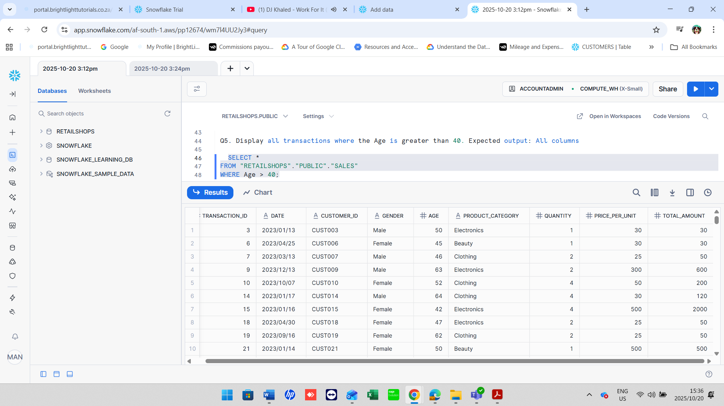

**Q6.** Display all transactions where the Price per Unit is between 100 and 500. *Expected output:* All columns

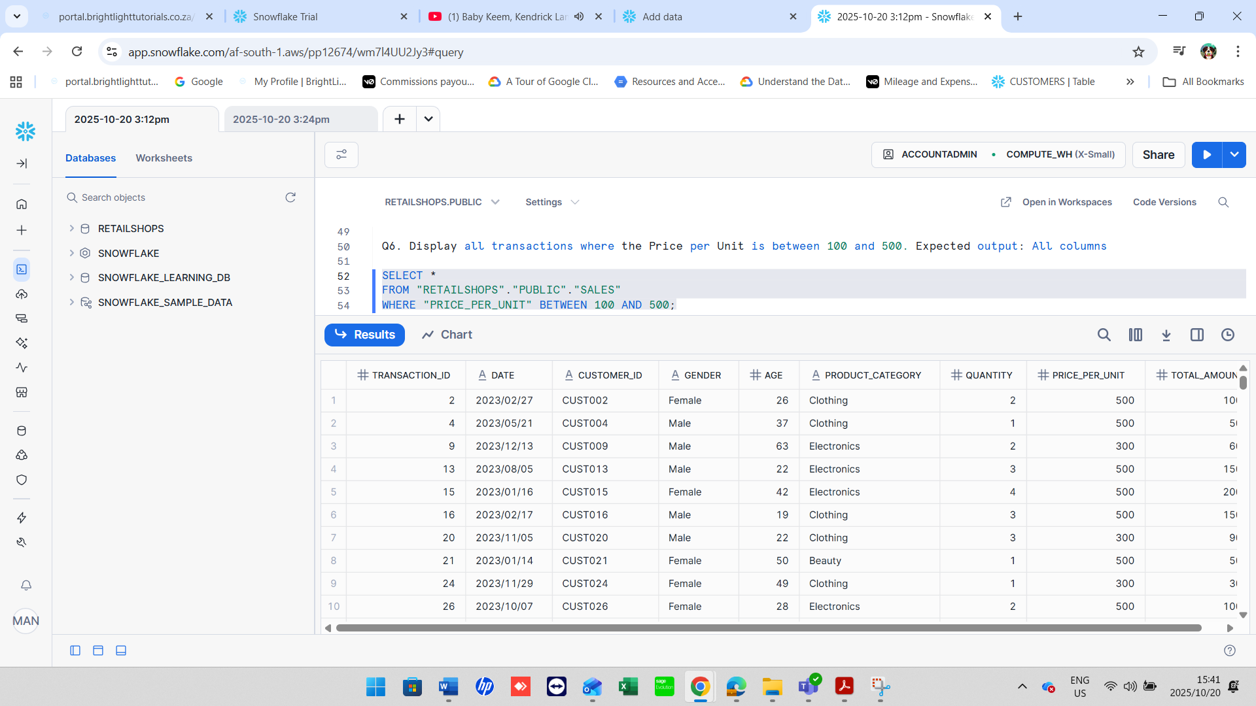

**Q7.** Display all transactions where the Product Category is either 'Beauty' or 'Electronics'. *Expected output:* All columns

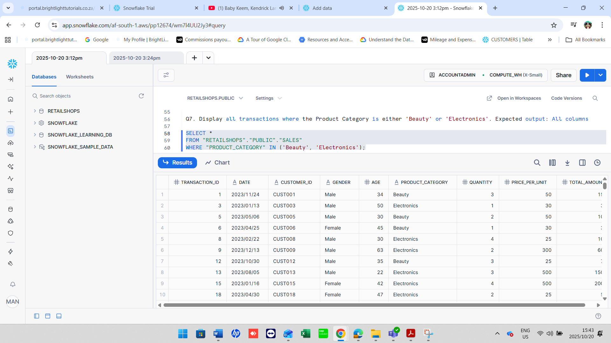

**Q8.** Display all transactions where the Product Category is **not** 'Clothing'. *Expected output:* All columns

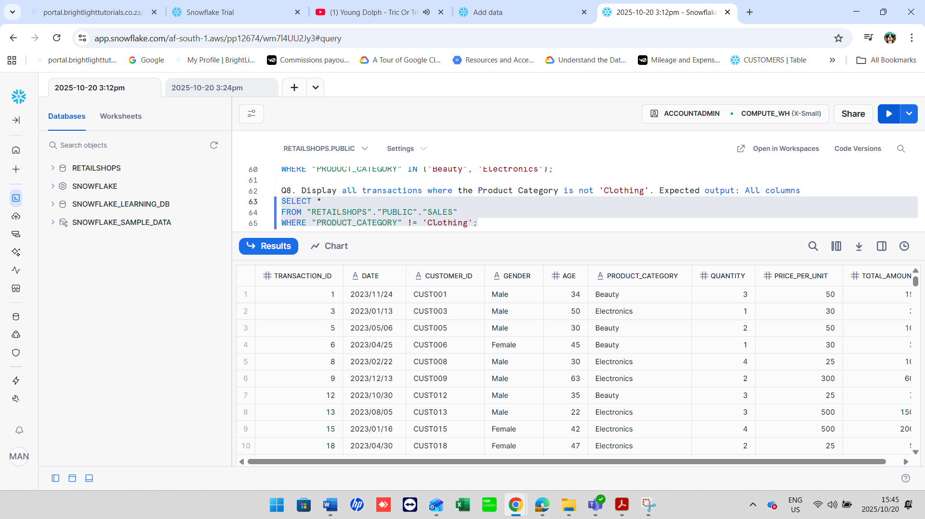

**Q9.** Display all transactions where the Quantity

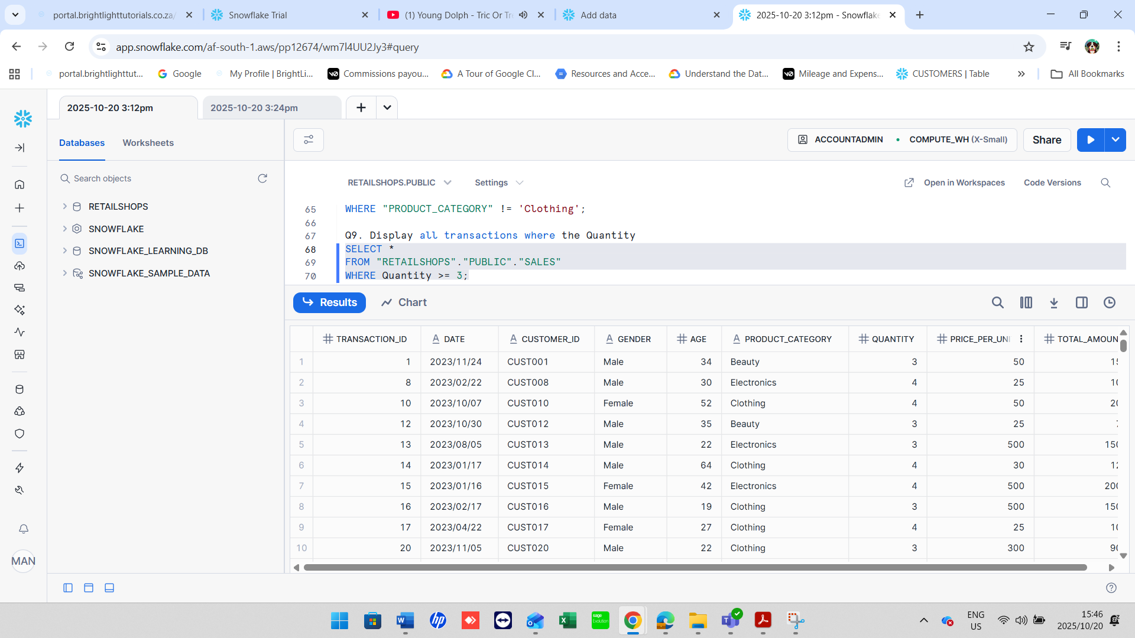

**4. Aggregate Functions**

**Q10.** Count the total number of transactions. *Expected output:* Total_Transactions

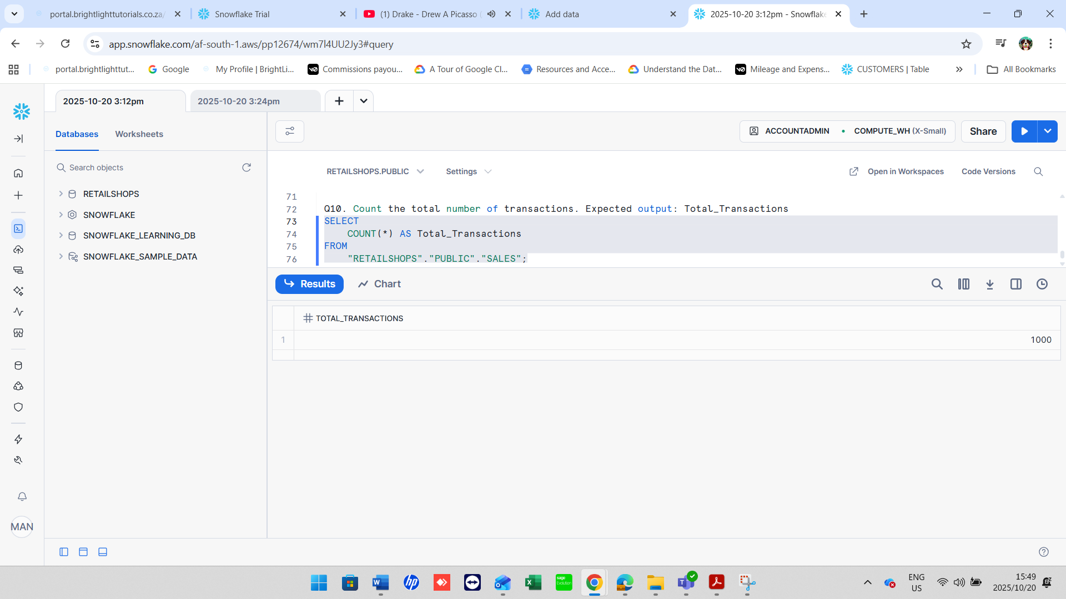

**Q11.** Find the average Age of customers. *Expected output:* Average_Age

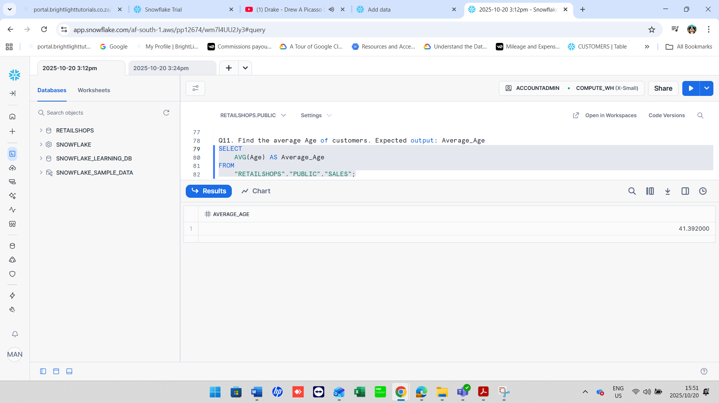

**Q12.** Find the total quantity of products sold. *Expected output:* Total_Quantity

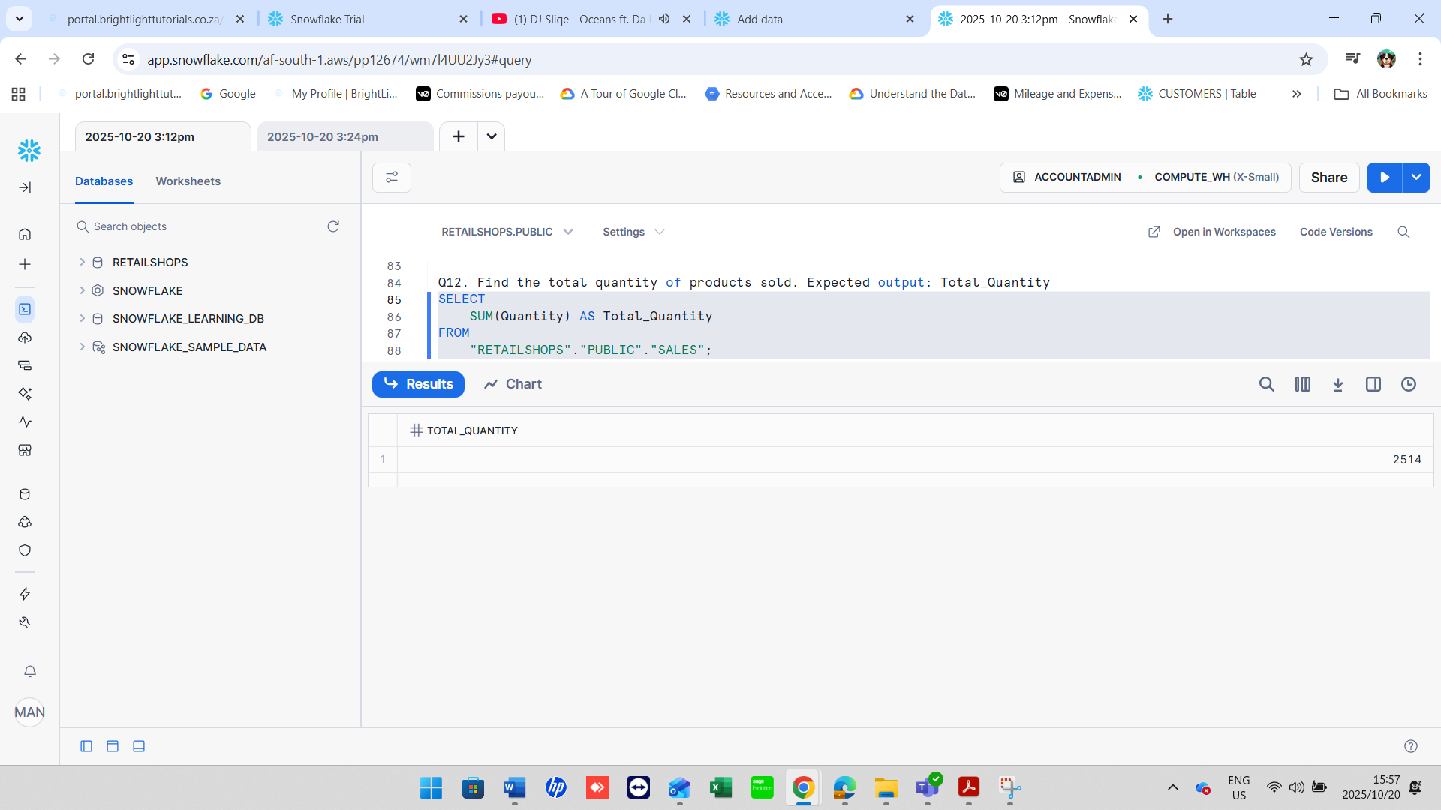

**Q13.** Find the maximum Total Amount spent in a single transaction. *Expected output:* Max_Total_Amount

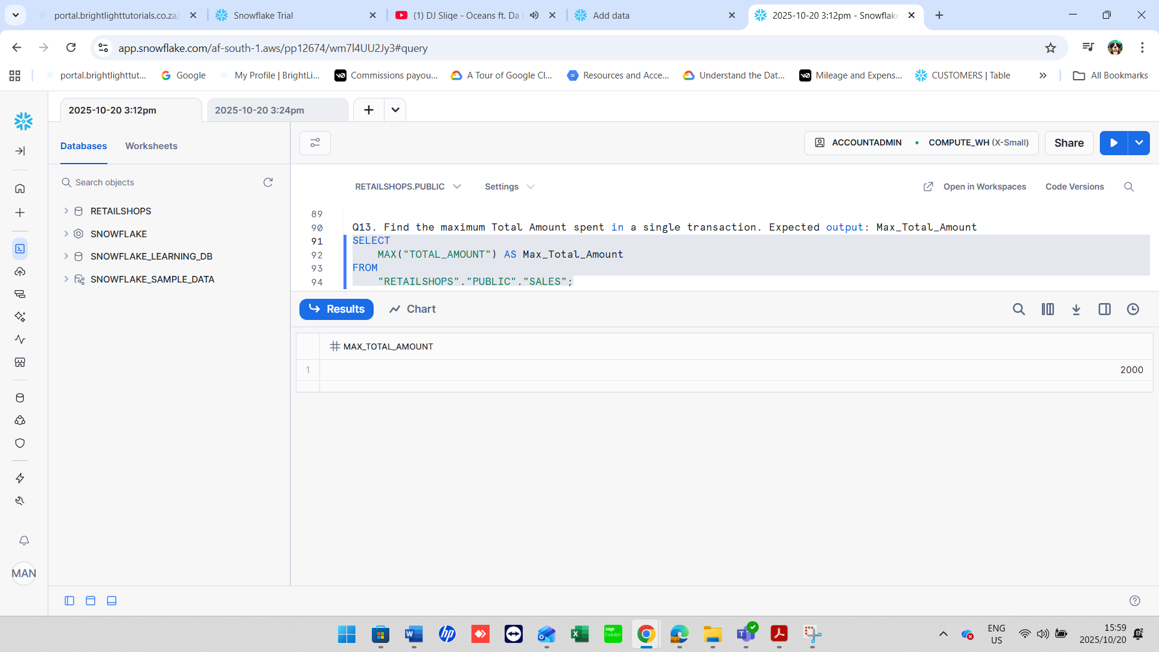

**Q14.** Find the minimum Price per Unit in the dataset. *Expected output:* Min_Price_per_Unit

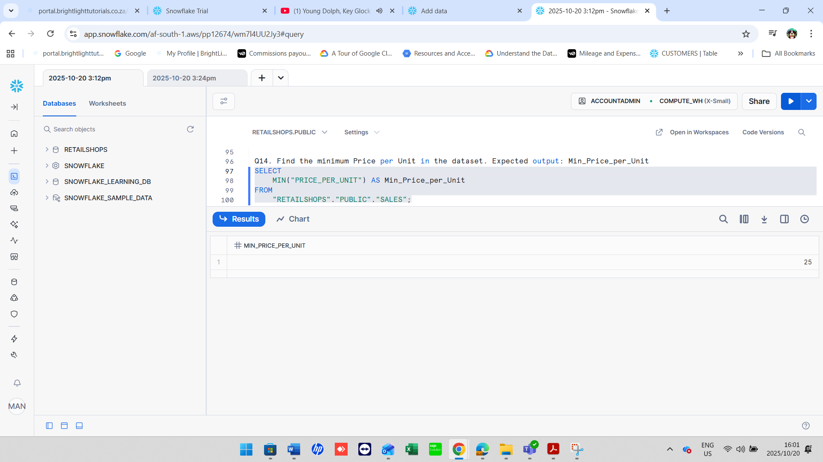

5. GROUP BY Statement

**Q15.** Find the number of transactions per Product Category. *Expected output:* Product Category, Transaction_Count

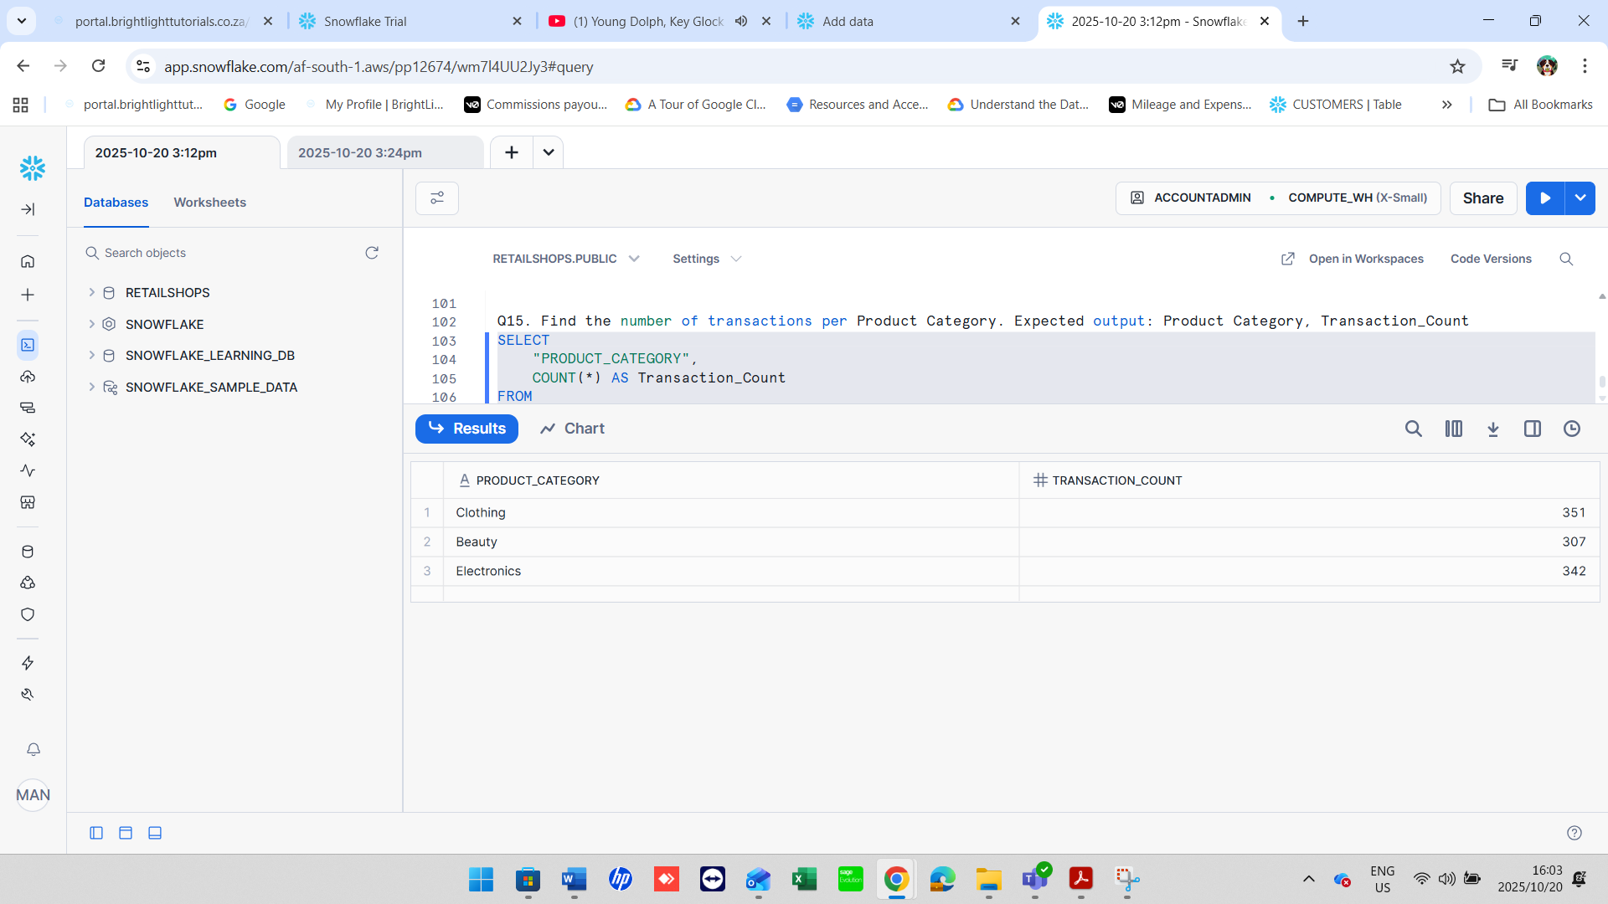

**Q16.** Find the total revenue (Total Amount) per gender. *Expected output:* Gender, Total_Revenue

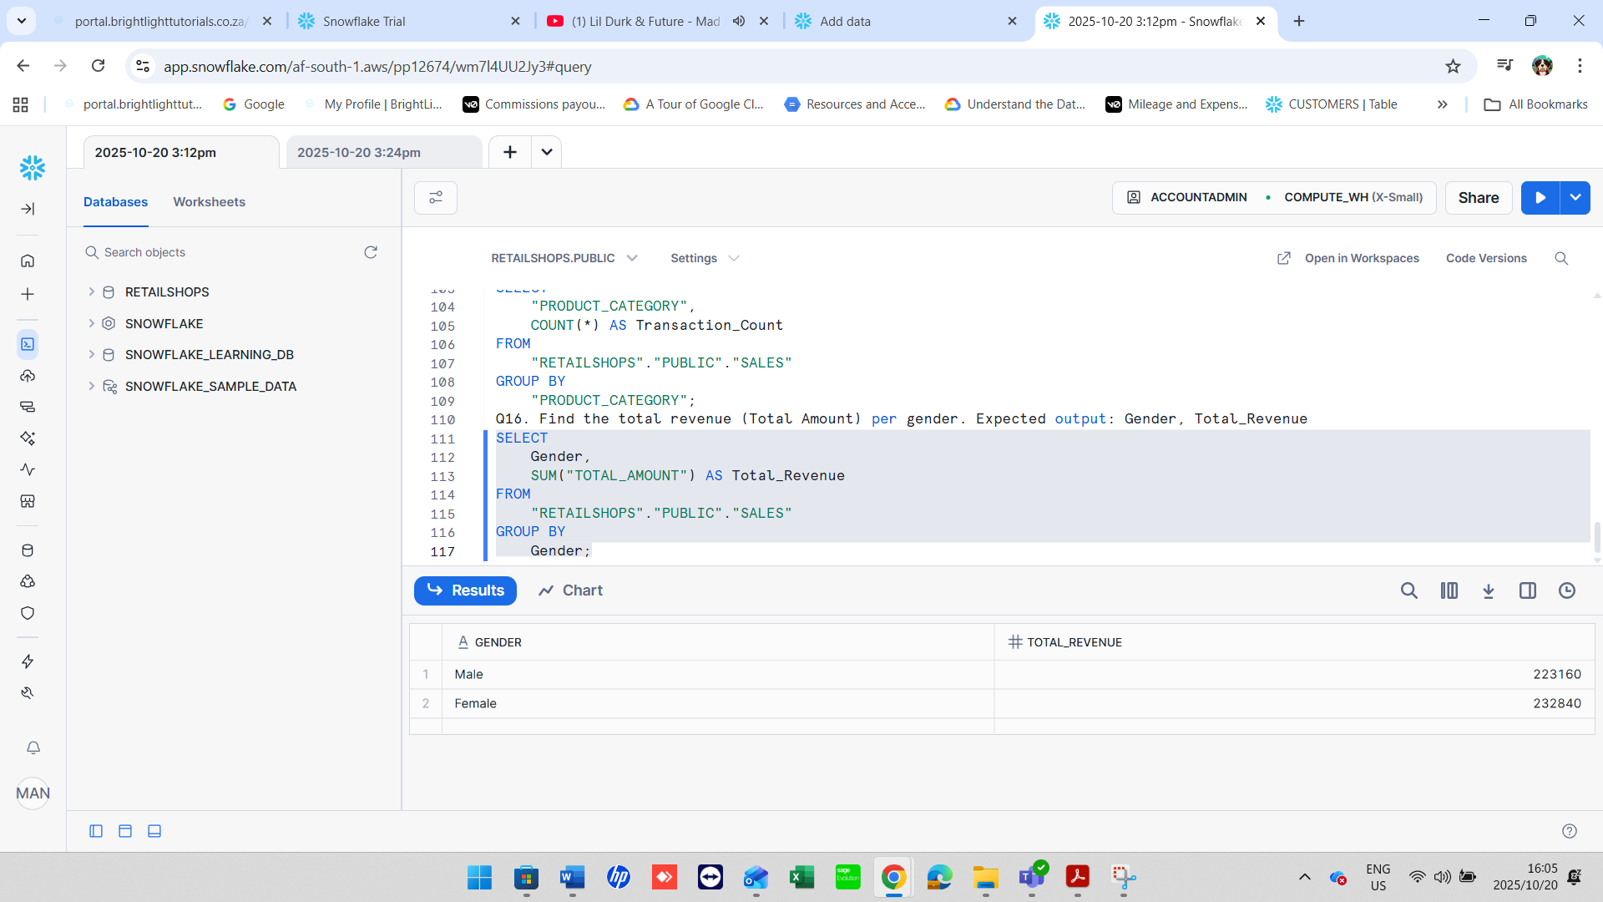

**Q17.** Find the average Price per Unit per product category. *Expected output:* Product Category, Average_Price

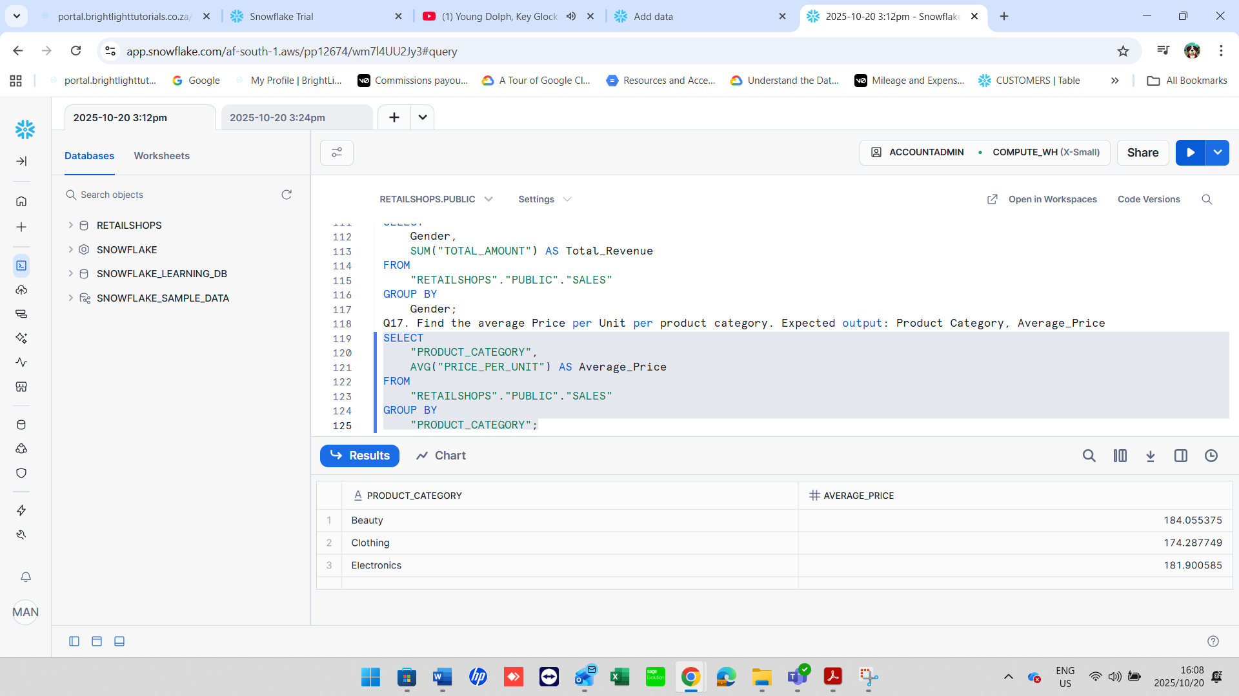

**6. HAVING Clause**

**Q18.** Find the total revenue per product category where total revenue is greater than 10,000. *Expected output:* Product Category, Total_Revenue

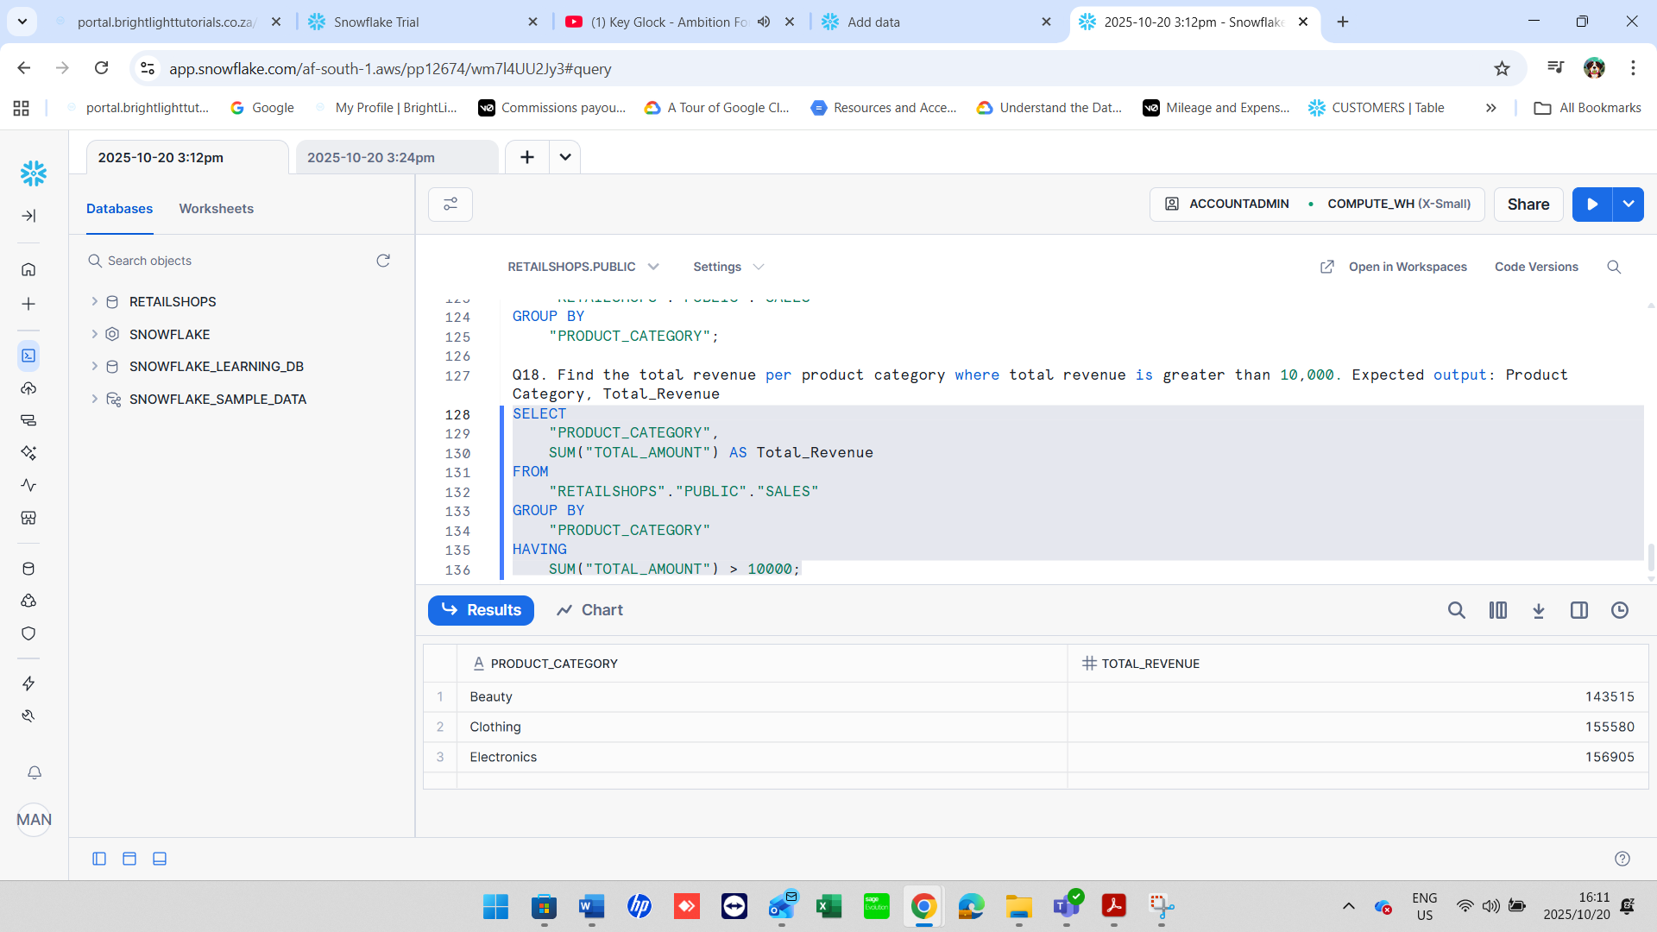

**Q19.** Find the average quantity per product category where the average is more than 2. *Expected output:* Product Category, Average_Quantity

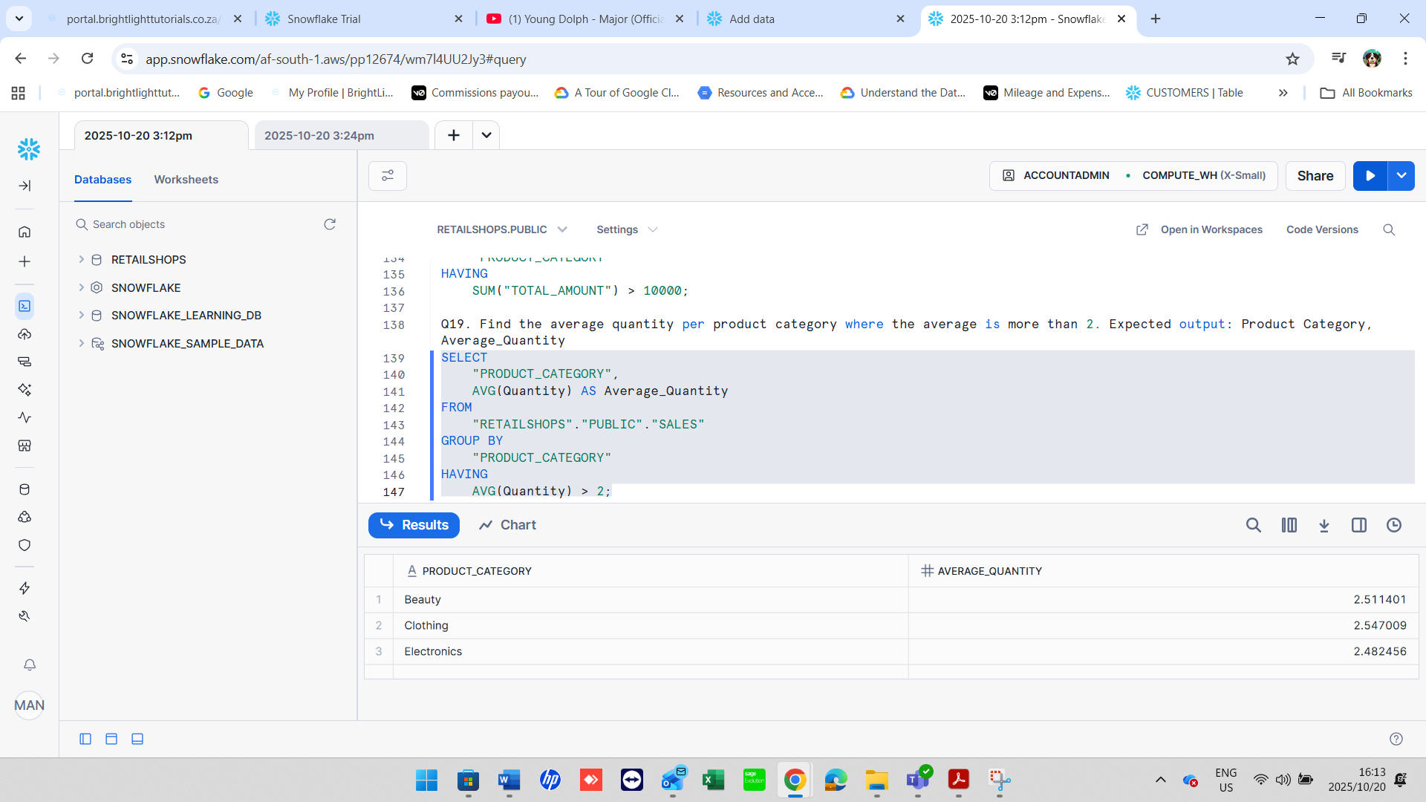

7. CASE Statement

**Q20.** Display a column called Spending_Level that shows 'High' if Total Amount > 1000, otherwise 'Low'. *Expected output:* Transaction ID, Total Amount, Spending_Level

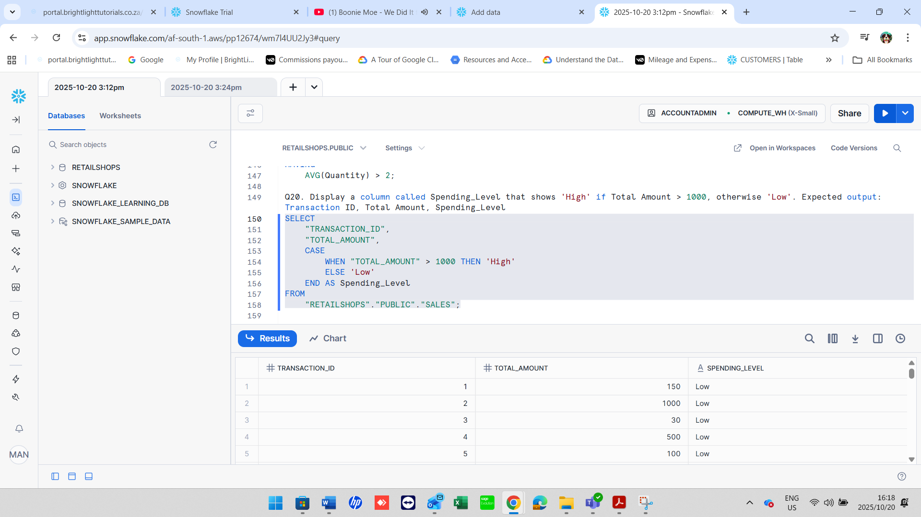

**Q21.** Display a new column called Age_Group that labels customers as:

* 'Youth' if Age < 30
* 'Adult' if Age is between 30 and 59
* 'Senior' if Age >= 60 *Expected output:* Customer ID, Age, Age_Group

